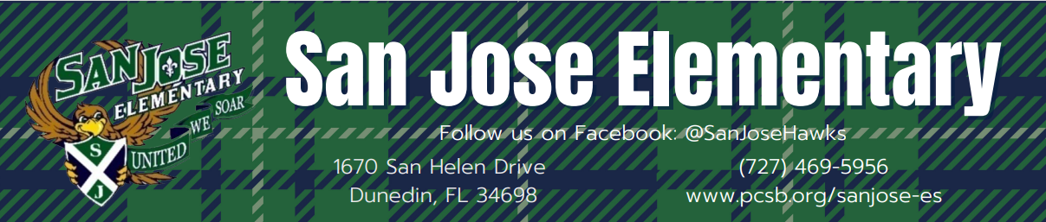
School Improvement 2023-2024
Vision: 100% Student Success 100% of the time
Mission: Create a safe learning environment which promotes academic excellence for college, career, and life readiness through the partnership of students, staff, families, and community.

Goals
 | ELA Gr 3-5  Proficiency | Math Gr 3-5  Proficiency | Science Gr 5  Proficiency | ELA Gr 3  Proficiency
2022-23 | 60% | 77% | 79%
2023-24 Goals | 65% | 80% | 80% | 70%
Action Steps
- Intentional planning through cross curricular collaboration.
- Differentiated Instruction for all students.
- Strengthen student inquiry skills through highly engaging project-based learning.
- Student engagement in STEM lessons.
- Utilize a system of recognition for students demonstrating positive behaviors.
- Build and maintain positive relationships with students and families through mutual respect and trust.

